Minimum Distance Separation I (MDS I) Data Sheet
This is to be completed and attached to the application when applying for a new non-farm use proposed within 750m (approximately 2,500ft) of an existing livestock facility, manure storage, anaerobic digestor or stockyard, for Type A land uses (see attachment 1) and within 2,000m (6,562 ft) of an existing livestock facility for Type B land uses (see attachment 1). Please complete one sheet for each set of livestock facility within these distances.
File number_________ | Applicant | Owner of Adjacent Livestock Facility
Name
Address
Geographic Township
Lot
Concession
Roll No.
Telephone
Fax
Email

MEASUREMENT REQUIREMENTS:

- Rezoning or Redesignation: Measure from the shortest distance between the area to be rezoned or redesignated and the livestock occupied portion of the facility.

- New Lot Creation: Measure from the shortest distance between the lot created to the livestock occupied portion of the facility.

- Development on Existing Lot: Measure from the shortest distance between the dwelling or other structures to be constructed and the livestock occupied portion of the facility.

- Maximum tillable hectares on the lot with the livestock facilities ____________ Ha ____________Ac
Source: _______________________________________

- Actual distance from the livestock facility to the proposed use ____________ metres___________feet
Source: _______________________________________

- Actual distance from the manure storage to the proposed use____________ metres ___________feet
Source: _______________________________________

NOTE: Planning staff may request a survey if the actual setback distance is within close proximity to the required setback distance.

Animal Type  or Material  (from Table 1, attachment 2) | Description  (from Table 1, attachment 2) | Manure types (from table 5, attachment 3) | Total Maximum Housing Capacity | Number per NU  (from Table 1, attachment 2) | Existing NU | Factor A  (from Table 1, attachment 2) | Factor D  (from Table 1, attachment 2)
(Example)  Swine | Sows with litter | V3 | 10 | 2 | (10/2=5)  5 | .7 | .7
1.

2.

3.

4.

The above information was supplied by: ______________________________________________

This information is true to the best of my knowledge.

_______________________________________ _______________________________________
Signature Date
Attachment 1: Type A and B Land Uses
Type A Land Uses:
Type A land uses are typically characterized by uses that have a lower density of human occupation, habitation or activity.
For the purpose of MDS 1, Type A land uses include applications to rezone or redesignate agricultural lands for Industrial, agricultural-related or recreational use- low intensity purposes.
Type A land uses include applications to permit:
- Construction of a dwelling on an existing lot where the municipality has determined the MDS I should be applied, or the
- Creation of up to three lots either by consent or plan of subdivision.
Type B Land Uses:
Type B land uses are typically characterized by uses that have a higher density of human occupation, habitation or activity.
For the purpose of MDS 1, Type B land uses include applications to rezone or designate agricultural lands for residential, recreational use- high intensity, commercial or settlement area purposes.
Type B land uses include applications to permit:
- Creation of residential subdivisions in rural areas, or
- Expansion of a settlement area, or
- Creation of multiple residential deveopment, or
- The creation of a lot which results in a rural residential cluster

Attachment 2: Table 1

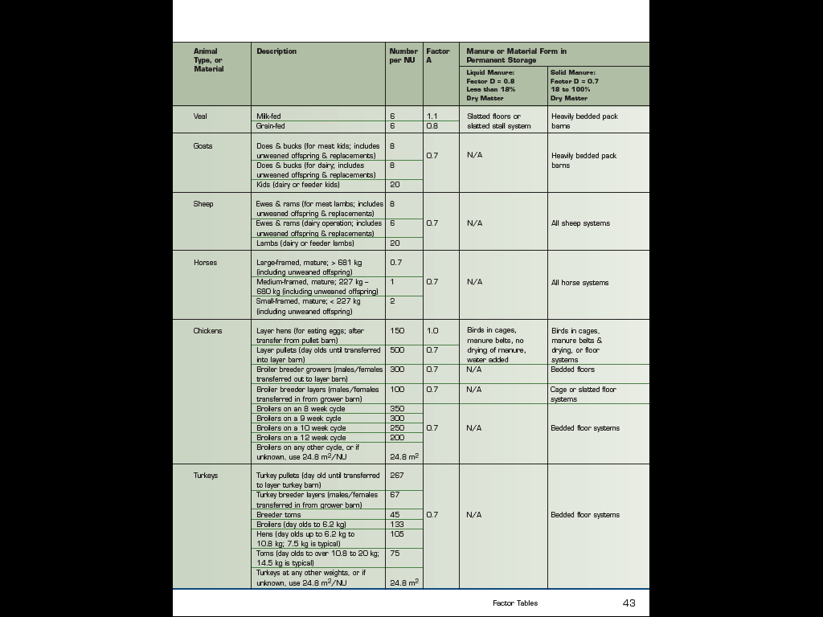

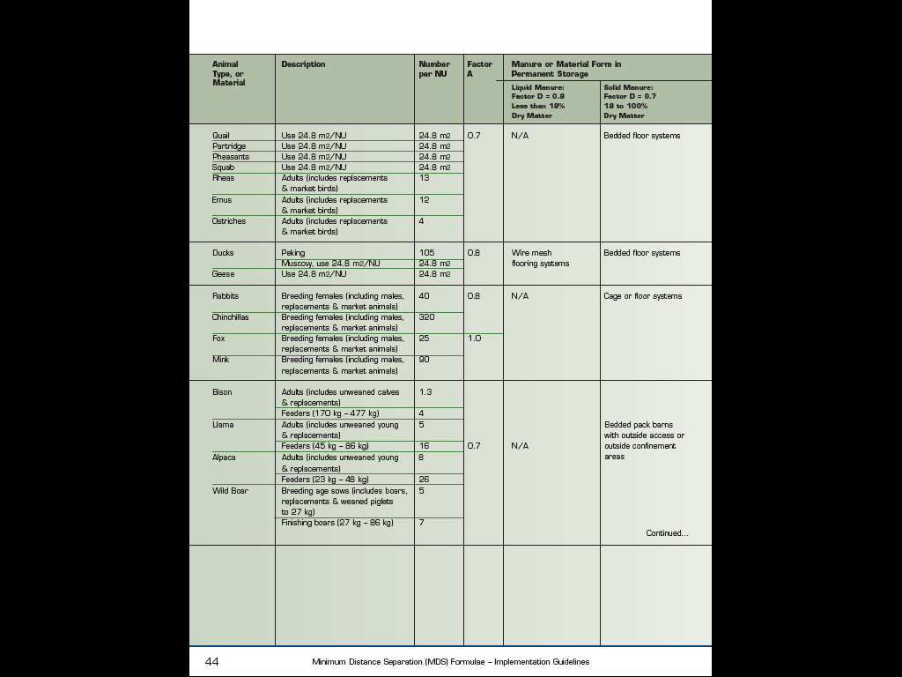

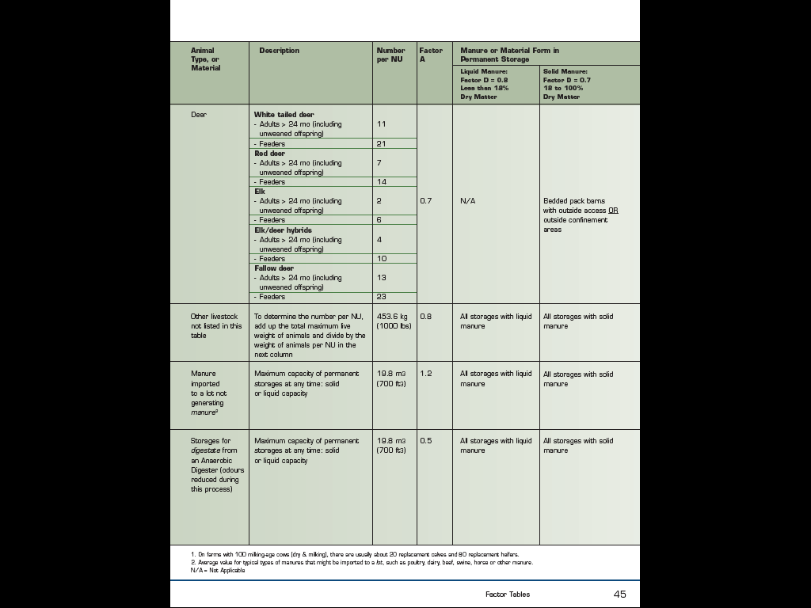

Attachment 3: Table 5

