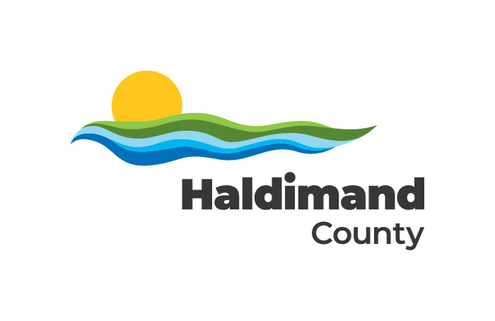

2022 Accessibility Annual Status Update

Accessibility Annual Status Update: 2022

Accessibility Status Report
This Accessibility Status Report serves as an update on progress made towards meeting the initiatives listed in Haldimand County’s 2017-2022 Accessibility Plan, the implementation of the Accessibility for Ontarians with Disabilities Act, 2005 (AODA) and the Integrated Accessibility Standards Regulation (Ontario Regulation 191/11).
Under the AODA, municipalities are required develop Annual Accessibility Status Reports yearly and make those reports publicly available through the website.
Every two years, municipalities are required to submit additional AODA compliance reports directly to the Government of Ontario. The last AODA compliance report submitted to the Province was in 2021, and as such, there will be no further compliance reporting requirements to the Government of Ontario until 2023.

Haldimand County’s Commitment to Accessibility Planning
Through accessibility planning and with the advice of the County’s Accessibility Advisory Committee, Haldimand County will strategically identify, remove and prevent as many barriers as possible.
Haldimand County is Committed to:
- The continual improvement of access to all municipally owned facilities, premises and services for all those with disabilities.
- The provision of quality services to all members of the community with or without disabilities.

Development of the 2023-2027 Accessibility Plan
The 2023-2027 Accessibility Plan outlines and details the actions that Haldimand County will undertake to identify, remove and prevent barriers for people with disabilities who utilize the goods, services, and facilities of Haldimand County.
Haldimand County’s current Accessibility Plan expires at the end of 2022. The DRAFT 2023-2027 plan has been prepared and will be presented to Council in Q1 of 2023 for consideration and approval.
To ensure the 2023-2027 plan was informed by community needs and insight, a survey was conducted to gather input from residents as to what elements they would like to see included in the plan, as well as areas of importance to focus on. With consideration given to community input received and forward momentum achieved over the past year, the new plan will:
- Describe the process by which the County will identify, remove and prevent barriers to people with disabilities.
- Review earlier efforts to remove and prevent barriers to people with disabilities.
- Review the facilities, policies, programs, practices and services in the County to identify barriers to people with disabilities.
- Continue to access community input and feedback to ensure collaboration and partnership to help guide and shape our community goals

2022 Summary of Accessibility Accomplishments

General
- Hired a permanent part-time Accessibility Coordinator to act as a designated resource for corporate accessibility matters
- Developed and took steps towards implementing the County’s new multi-year Accessibility Plan for 2023-2027
- Prepared the Annual Accessibility Status Report of measures set out in the multi-year accessibility plan, posted it on the County’s website and provided it in an accessible format, upon request.
- Posted accessibility policies and procedures on the website and provided them in an accessible format, upon request.
- Continued to implement purchasing policy, which requires suppliers and their staff to comply with the AODA when acquiring goods, services and facilities.
- Drafted a comprehensive Facilities Accessibility Design Standards (FADS) to be presented to Council for adoption in 2023.

Customer Service Standard
- Continued to post service disruption notices at affected facilities, on the County’s website and through social media channels.
- Continued to provide access to alternate facilities or services wherever possible
- Introduced mandatory Ontario Human Rights Code training for all staff
- Significantly enhanced training provided around accessibility to all new hires
- Improved staff training materials and introduced new learning resources via employee intranet

Information and Communications Standard
- Introduced several changes to the Haldimand County website to ensure that all community members, regardless of their abilities, have equal, barrier-free access to municipal information
- Introduced UserWay software on the Haldimand County website to provide a more accessible and inclusive experience for a wide variety of disabilities
- Continued to receive and follow up on feedback in regards to municipal goods, services and facilities
- Continued to ensure processes for receiving and responding to feedback are accessible for persons with disabilities by providing/arranging for accessible formats and communications supports, upon request.

Design of Public Spaces Standard
- A number of new parks were constructed, or had equipment replaced to meet accessible standards.
  - Williamson Woods Park (Equipment Replacement, Caledonia)
  - Townsend Park (Equipment Replacement, Townsend)
  - Nanticoke Springvale Park (Equipment Replacement, Springvale)
- A Hearing Loop system designed for hearing aid support was installed at first and second floor service counters at the Haldimand County Administration Building
- A wheelchair accessible ramp was installed at Wilson MacDonald Memorial School Museum
- Site and floor plan design for major public spaces reviewed and approved by Accessibility Advisory Committee (e.g. New Caledonia Fire/EMS Station plans, Selkirk Waterfront Way proposed enhancements, on-street patios, Jarvis Disc Golf course, etc)

Employment Standard
- Continued to notify the public about the availability of accommodations for applicants with disabilities in the recruitment process.
- Acknowledgement statement on job applications includes statement of availability of accessibility accommodations in recruitment process.
- Continued to notify candidates for employment of the availability of accessibility accommodations when contacted for an interview or assessment.
- Offered support to employees who require temporary or permanent work accommodations and maintain a return to work employment accommodation program.
- Continued to inform new employees of policies and procedures to support employees with disabilities during on-boarding and orientation.

Transportation Standard
- Continued to communicate and advise private transportation companies (Taxicab Operators and Drivers) on the requirements of the Transportation Standard including fare restrictions and the posting of vehicle registration and identification information.
- Monitored Taxi industry and ensured compliance with Accessible Taxicab requirements.
- Ensured Accessible Taxicabs meet all safety requirements stipulated through the County’s Hired Vehicle Licensing By-law.
- Continued to ensure every licensed driver of an Accessible Taxicab notifies passengers upon arrival, offers such assistance as the passenger requires, and properly and safely handles passenger mobility aids.

2023 Goals and Next Steps

Goals
- Obtain Council approval to adopt the 2023-2027 Accessibility Plan
- Collaborate with key internal stakeholders to finalize Facility Accessibility Design Standards and see them officially adopted by Council
- Update the Accessibility Standards for Customer Service Policy 2009-02 and with Council approval, implement them across the corporation
- Recruit, train and continue to work with the new 2022-2026 Accessibility Advisory Committee for the next term of Council
- Embark on the process of redesigning the County’s website to ensure that it meets WCAG 2.1 AA standards
- Monitor and update existing accessibility policies, as appropriate.
- Review customer feedback and make changes to programs or services, where appropriate.
- Continue to keep abreast of accessibility issues, innovations and trends.
- Consult the public, persons with disabilities and the Accessibility Advisory Committee

Next Steps
- Continue to develop and enhance training materials for all staff, volunteers, and new hires as AODA standards and regulations evolve.
- Prepare for National Accessibility week (May 28-June 3, 2023) and promote the event as an annual occurrence.
- Ensure that Haldimand County’s digital footprint is in compliance with regulated standards
- Develop a Facilities Accessible Design Audit checklist
- Conduct a County wide audit of all Haldimand County-owned facilities to identify where there are gaps
- Report and work towards correcting the gaps that have been identified through the audit

Contact Information
For more information about accessibility initiatives within the County or to obtain a copy of this presentation in an alternative format, contact the Supervisor, Customer Experience & Communications.

Phone: 905-318-5932 ext. 6186
E-mail: accessibility@haldimandcounty.on.ca

