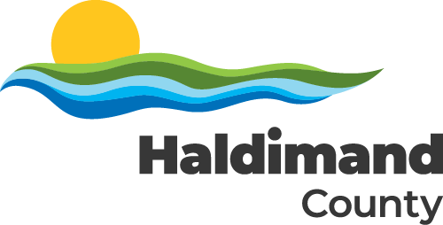

Volunteer Insurance Coverage – Acknowledgement

As a volunteer for Haldimand County you have the right to know that you are covered under the County’s liability policy for those activities you perform as a part of the activity to be undertaken. This liability policy protects the Corporation and the volunteer against claims brought against them by third parties. It does not, however, cover loss or damage to a volunteer’s property. Similarly the County does not provide coverage for personal injuries that may occur to volunteers while undertaking their activities, either through the policies of the Corporation or through Workplace Safety and Insurance Board provisions. The volunteer must ensure their personal safety through provision of appropriate personal protective equipment where required.

I have read and understand the insurance provisions as outlined above.

Date Print Name of Volunteer

Signature

Signature of Parent/Guardian, Print Name of Parent/Guardian
if Volunteer is under age 18.

