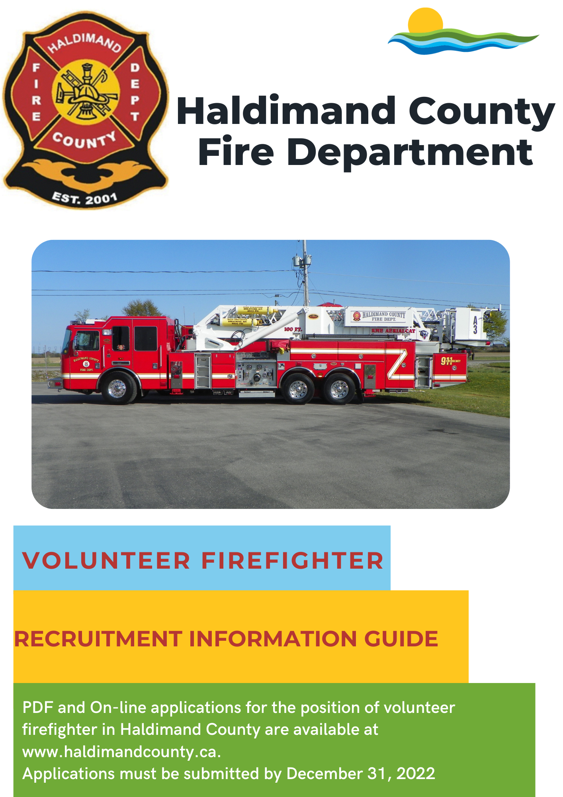

Message from the Fire Chief:

The provision of Emergency Services is a complex and continually evolving field. It requires dedicated staff who are willing to adapt to changes, work hard and continuously train to meet the needs of the community.

The role of today’s firefighter is substantially different than years past and involves training and readiness for response to emergencies and a renewed focus on preventing fires and fire-related injuries and deaths through public education and enforcement of the Ontario Fire Code.

The Emergency Services Division strives to provide the residents and visitors of Haldimand County with prompt, professional and compassionate service of well trained and well equipped paramedics and firefighters. We take seriously the importance of the role of responding to assist people during their time of need and maintain our commitment to provide high level service.

Being a volunteer firefighter offers one reward few other opportunities can match. Few positions offer you the opportunity to save a life. But as a volunteer firefighter, you could be called upon to do it at a moment's notice.

That's why we need people with a strong desire to help others. And people with courage and dedication to the work they do. Because this position is so important, we make sure all of our volunteer firefighters are well trained and properly equipped.

So if you want to do something important for your community and are willing to take on a challenging opportunity, being a volunteer firefighter may be the opportunity for you.

Sincerely,

Jason Gallagher

Fire Chief
Haldimand County

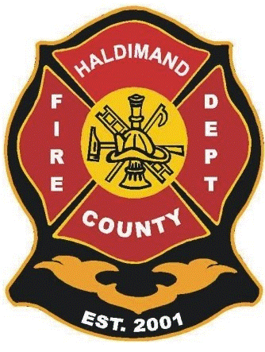

HALDIMAND COUNTY FIRE DEPARTMENT
RECRUITING FOR VOLUNTEER FIREFIGHTERS
The Haldimand County Fire Department is committed to protecting the lives and property of our citizens and visitors by providing prompt and professional services in the event of fire, accident, medical emergency, disaster or any other event which may threaten the public welfare.
If you enjoy serving the public, and are willing to dedicate the time required to successfully complete a training program, attend regular weekly and mandatory training sessions and respond frequently to emergencies within your assigned area, this could be your opportunity to make a difference in your community. We invite you to participate in this opportunity by applying for the position of

VOLUNTEER FIREFIGHTER
The Haldimand County Fire Department operates out of 11 stations strategically placed throughout the County. As a member of this dedicated team, you will respond to firefighting and rescue operations, operate and maintain fire apparatus and equipment, and participate in public relations and education.
If anyone is interested in receiving more information about this opportunity, please contact Barb Lomnicki at 905-318-5932 ext. 6224 or email at blomnicki@haldimandcounty.on.ca .
PDF and On-line applications for the position of volunteer firefighter in Haldimand County are available at www.haldimandcounty.ca under the Services tab, Emergency Services, Fire Services and then Becoming a Volunteer Fire fighter.

Recruitment QR Code
Please submit no later than December 31st, 2022

Job Description for the Position of
VOLUNTEER FIREFIGHTER

Summary of Duties

To perform firefighting duties and other related work as required. The position is manual work of a hazardous nature involving the fighting of fires, rescue work and patient care generally performed under the direct supervision of fire officers. All firefighters will be required to be certified to the National Fire Protection Association Standard, Standard for Fire Fighter Professional Qualifications and NFPA 1072 Hazmat Operations. Regular training and maintenance work of the fire station and equipment is required. There may be times when Firefighters may be required to make decisions and work without supervision until an officer arrives on scene. Must be able to work in a team environment under the direction of officers adhering to all established policies, operational guidelines and the Occupational Health and Safety Act. The work of the Volunteer Firefighter is performed under the broad supervision of the Captains and District Chiefs.

Duties
- May respond to emergency calls 24 hours per day, 7 days per week in accordance with attendance policies. May involve working on weekends, holidays and in all types of weather conditions.
- Lays and connects hose, holds nozzles and directs water streams, raises and climbs ladders, uses extinguishers, fans, pumps, saws and other equipment
- Enters burning or contaminated buildings, structures, and other areas to perform rescues and/or fight fires while wearing appropriate firefighting equipment as supplied by the fire service
- Wears and properly uses all appropriate equipment as supplied by the Haldimand County Fire Department
- Maintains all equipment in good condition
- Provides patient care as required
- Drives and operates firefighting and emergency equipment, as well as personal vehicles, safely and in accordance with polices and applicable legislation
- Carries out work as directed in an emergency situation
- Communicates appropriately in accordance with established guidelines
- Attends training sessions to maintain and upgrade firefighting skills in accordance with established polices and operational guidelines
- Performs other related duties as assigned

Responsibilities
- Works in accordance with established policies, operational guidelines and the Occupational Health and Safety Act
- Stays away from any fire service operations while under the influence of alcohol and/or prescription drugs which cause impairment
- Must maintain a high degree of confidentiality at all times
- Refrains from disclosing information to the news media or other persons without authorization from the Fire Chief
- May act in the capacity of a Captain as assigned when qualified as an Acting Captain through the Captain promotional policy.
- Must maintain a professional and respectful image both on and off duty.
- Must respect the chain of command at all times.

ABOUT US:
Mission Statement:

The mission of the Haldimand County Emergency Services Division is to protect the lives and property of our citizens and visitors by providing prompt and professional services in the event of fire, accident, medical emergency, disaster or any other event which may threaten the public welfare.

We will service the community through fire and accident prevention, public education and the immediate response to emergencies.

Vision Statement:

We will provide high quality and caring services to those who live in, work in and visit our County - safely, efficiently and effectively.

In order to fulfill this vision, we pledge to learn from our past, train for the present and plan for the future.

How We Will Achieve Our Vision and Mission

- Provide highly trained and skilled staff
- Reduce the incidence of injury, loss of life and property damage by providing public education programs, accident and injury prevention and fire prevention service
- Conform to legislation, regulations, standards and policies thereby mitigating liabilities/losses to the County’s assets
- Be responsive to local economics so that our service model reflects the needs of the community we serve
- Treat all persons with respect, compassion and dignity

Core Organizational Values

Safety

- Providing the Safety & Welfare of the Public as well as our Employees will be top priority.

Integrity

- Demonstrate respect, honesty, loyalty and honour in our dealings with others
- Lead through example
- Exercise due diligence

Respect

- Maintaining respect regardless of age, ethnicity, religion, national origin or economic status for:
  - The organization
  - The County
  - The Employees
  - Those in need

Service Excellence

- Commit to on-going personal and professional development to expand our skills and knowledge
- Demonstrate commitment to achieving our shared goals, values and vision
- Strive for excellence

Haldimand County Emergency Services encompasses the following areas of responsibility:
- Haldimand County Fire Department
- Haldimand County Paramedic Services
- Community Emergency Management Program
- Public Access Defibrillation Program
- Flood Co-ordination
- Pandemic Planning
The Haldimand County Fire Department operates out of 11 stations strategically placed throughout the County. As a member of this dedicated team, you will respond to firefighting and rescue operations, operate and maintain fire apparatus and equipment, and participate in public relations and education.

The department employs a full-time Fire Chief, Deputy Fire Chief, Fire Training and Health & Safety Coordinator, 2 Fire Prevention Officers, 1 Part Time Coordinator of Emergency Management and 2 administrative staff and a complement of 274 volunteer firefighters. The Haldimand County Fire Department responds to approximately 1000 calls per year.

STATIONS

- Station #1 – Caledonia 18 Caithness St West
- Station #2 – Hagersville 124 Main St South
- Station #3 – Jarvis 2985 Hwy #6 South
- Station #4 – Cayuga 11 Thorburn St South
- Station #5 – Canfield 357 Haldimand Hwy #56
- Station #6 – Canboro 7 Darling St
- Station #7 – Lowbanks 2633 North Shore Dr
- Station #9 – Dunnville 111 Tamarac St
- Station #11 – South Haldimand 283 Haldimand Rd #50
- Station #12 – Fisherville 24 Erie Ave South
- Station #13 – Selkirk 38 Main St West
VEHICLE TYPES AND QUANTITIES

Staff vehicles 5

Platform/Ladder aerial trucks 3

Pumpers 14
Tankers 11
Heavy rescue trucks 5
Light rescue 3

Squad 1

Rescue boats 4

TRAINING
Recruit firefighters are required to complete a 7 month recruit training program that meets requirements for NFPA 1001 Firefighter I & II including Hazmat NFPA 1072 by registered trainers.
This training is primarily held one weekend a month with from April until September with final exams October - November. There is substantial on-line pre-requisite work that needs to be completed prior to the assigned weekend. There is some additional in-house training required as well. At the end of this mandatory training the firefighter will achieve their NFPA 1001 Firefighter I & II including Hazmat 1072 after passing the required OFMEM exams and practical tests. All training is scheduled in advance. Online training will be required so there is a need for a personal computer and email address. Firefighters will not be compensated for training until successful completion of the 7 month training. Haldimand County Fire Department will pay for the recruits’ tuition. It is expected that firefighters will complete training as required or the firefighter may be removed from the training program at the discretion of the fire chief.
Volunteer firefighters attend the station weekly for on-going firefighter training, maintenance of equipment, trucks and the station, meetings, pre-planning, public education and other fire department functions.
There is also extra training offered on weekends on a voluntary basis, like auto and heavy extrication, live fire, pumper operations, ice and water rescue, officer development, etc.

VOLUNTEER FIREFIGHTER COMMITMENT
Firefighters are expected to attend a minimum of 30% of the emergency incidents, attend a minimum of 50% of weekly training sessions, maintain the current firefighter curriculum training, maintain current certification in CPR to the Health Care Provider Level/first aid/defibrillation, achieve and maintain a valid DZ driver’s license within the first 2 years, and maintain a clean criminal record.
COMPENSATION
The compensation package (2022 rates) for a recruit / 3rd class firefighter is as follows:
- $17.10 / hour (1 hour minimum) for response to emergency incidents until firefighter progresses to 2nd Class.
- $20.77 / hour for attending training
- $17.10 / hour for attendance at fire prevention/public education, meetings and maintenance activities.
- Mileage compensation for meetings and training that occur outside of your assigned district. The initial recruit training does not qualify for mileage compensation.
- Compensation is adjusted annually.
- A lump sum payment to each recruit upon completion of the recruit training program as explained above.
The benefits package (2022 rates) for a recruit / 3rd class firefighter is as follows:
- On Duty Accidental Death Benefits
- Member & Family Assistance Program (MFAP): MFAP provides members and eligible family members with access to free, professional and confidential counselling, coaching and consulting services. These services help employees manage personal, family or work-related concerns and to become more resilient.
ELEGIBILITY REQUIREMENTS
Applicants for the position of Volunteer Firefighter MUST:
- Be at least 18 years of age.
- Possess a valid Ontario driver’s license at a class “G” level or greater at the time of application, with a good driving record. A “DZ” level would be an asset. Candidates will be required to produce a current Ministry of Transportation driver’s abstract.
- Candidates will be required to undergo a vulnerable sector check.
- Aptitude Test
- Be medically fit to perform the duties of firefighter. Candidates will be required to produce a Volunteer Firefighter Medical Evaluation Report from their physician.
- Be physically fit to perform the duties of firefighter. Candidates will be required to successfully complete the Firefighter Screening Service Candidate Physical Ability
Test (CPAT).
- Have a reliable means of transportation to respond to their home station.
- Be willing and able to respond to an acceptable number of emergency incidents.
- Be willing and able to meet the attendance requirements of the fire department training program.
HIRING PROCESS
Step 1:
Applications available either PDF or on-line at www.haldimandcounty.ca under the services tab, then emergency services, fire services and becoming a volunteer fire fighter information section.
Step 2:
Applications received prior to December 31st, 2022 will be considered for the 2023 recruitment. If chosen for an interview, will be contacted by headquarters to confirm a date and time. An aptitude test will be included at the time of the interview.
Step 3:
Candidates chosen to proceed to the physical testing will be provided a conditional offer letter and scheduled for CPAT testing.
Step 4:
Candidates successful at the CPAT testing, will be required to submit all required documentation as set out in the conditional offer letter.
Step 5:
Human Resources Orientation will be required at Haldimand County Administration Office 53 Thorburn St S Cayuga.
Step 6:
Haldimand County Fire Department Recruit Orientation session will be required at Emergency Services Headquarters 11 Thorburn St South Cayuga.

CPAT QR CODE

For further information:
Haldimand County Emergency Services
Headquarters
11 Thorburn St South P O Box 911
Cayuga, ON N0A 1E0
905 318 5932 ext. 6224
www.haldimandcounty.ca
emergencyservices@haldimandcounty.on.ca

Thank you for your interest in the Haldimand County Fire Department.

